**1. Stock Market Variables:**

* The provided variables (Open, High, Low, Close, Adjusted Close, and Volume) are fundamental for historical trend analysis. These will be essential for:
  + **Analyzing price movement**: Using the relationship between opening and closing prices can determine if the stock went up or down on a given day.
  + **Calculating daily volatility**: The difference between high and low prices can be used to calculate daily price fluctuations, which might give insights into market behavior.
  + **Volume analysis**: A spike in trading volume, when correlated with price changes, can indicate significant market activity, which could be events like product launches or software updates.

**2. Features May Be Missing:**

While stock market variables are critical for traditional price prediction models, external factors—such as major technological releases and market sentiment—could play a crucial role in influencing NVIDIA's stock price movements. Here are some considerations:

* **Major Technological Releases (e.g., RTX series):**
  + To capture the impact of product launches like the RTX series, create event markers or add a feature that tracks the dates of these product launches.
  + Study whether price movements or volume changes before or after the release of significant products (e.g., RTX or GTX series).
* **Market Sentiment Data:**
  + Obtain sentiment data from social media, news outlets, or financial reports; you could integrate it into your model. This might capture the market's perception of NVIDIA's new releases or technological innovations, offering a more nuanced prediction.
  + For example, Natural Language Processing (NLP) techniques could quantify sentiment from financial articles and relate it to stock price movements.

**3. Volatility and External Events:**

* **Volatility Index**: Compute more refined volatility metrics, such as moving average volatility, to account for stock fluctuations over time.
* **External Macro Factors**: Stock prices often react to company-specific events and broader market conditions (e.g., economic downturns or policy changes in technology)—additional data on broader market trends or sector performance.

**4. Exploring Relationships Between Features:**

To ensure that the features are sufficient, it is essential to:

* **Check correlations:** Run a correlation matrix to see how each feature (e.g., volume, open price, volatility) correlates with the stock price movement. Identify which features are more predictive of price changes.
* **Feature Engineering:** If necessary, create additional features such as price change percentage, rolling averages of price, or moving averages of volume to smooth out short-term fluctuations and reveal longer-term trends.

**5. Addressing Time-Related Dependencies:**

* Time-dependent stock data accounts for lag effects (where today's price movement may depend on previous days).
* Consider creating lagged features, such as "Previous Day Close," "Previous Day Volume," etc., to include recent history in your predictive model.

**Additional Feedback on Driving Questions:**

* **What are the data limitations?**
  + The dataset does not currently include external influences such as broader market movements, technological news, or investor sentiment, which might affect NVIDIA stock price. Consider expanding the dataset or adjusting the questions to account for this.

**Summary of Adjustments You Might Need:**

* Add event markers for major releases (e.g., RTX series) to explore the direct impact on stock prices.
* Consider incorporating external factors like market sentiment or news to improve prediction accuracy.
* Examine volatility: Use price volatility (high vs. low) as an essential feature and test it in your model.
* Engineer lagged features to capture typical time dependencies in stock market data.

Visualizations:

* **Useful Visualizations:**
  + Candlestick Charts: Great for visualizing daily price movements (Open, High, Low, Close).

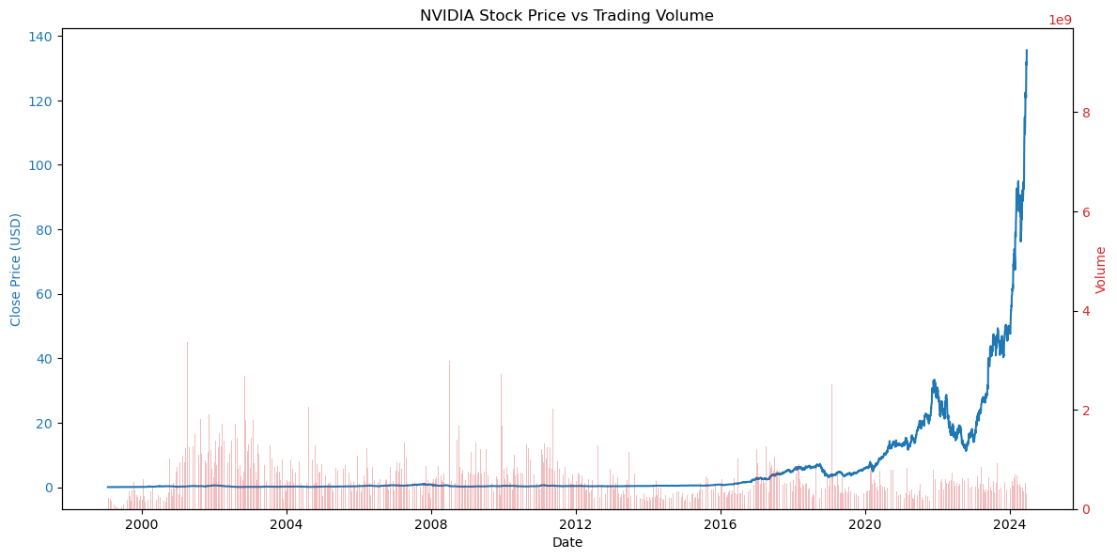

* + Volume vs. Stock Price: Helps highlight the correlation between stock trading volume and price changes.

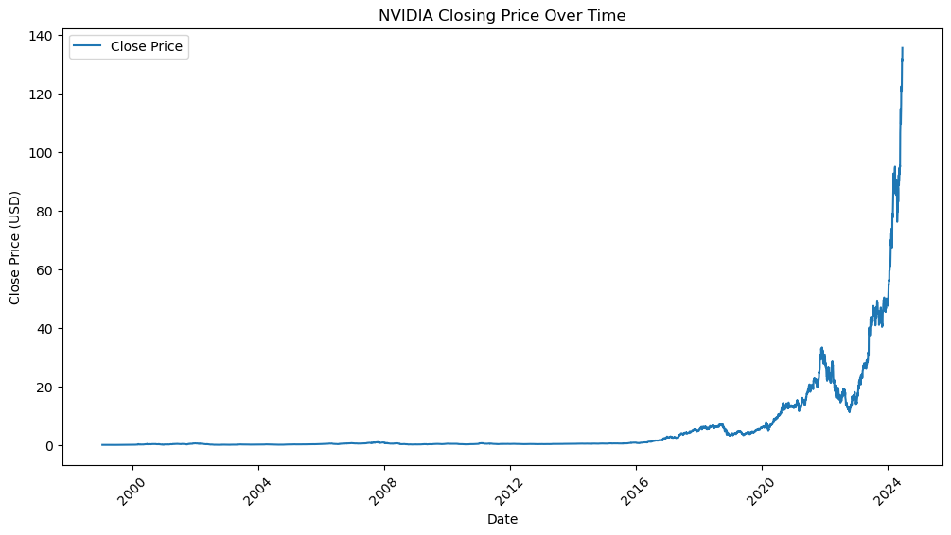

* + Price Movements Over Time: A line chart or a combination of line and bar charts shows NVIDIA stock price trends and volume over time.

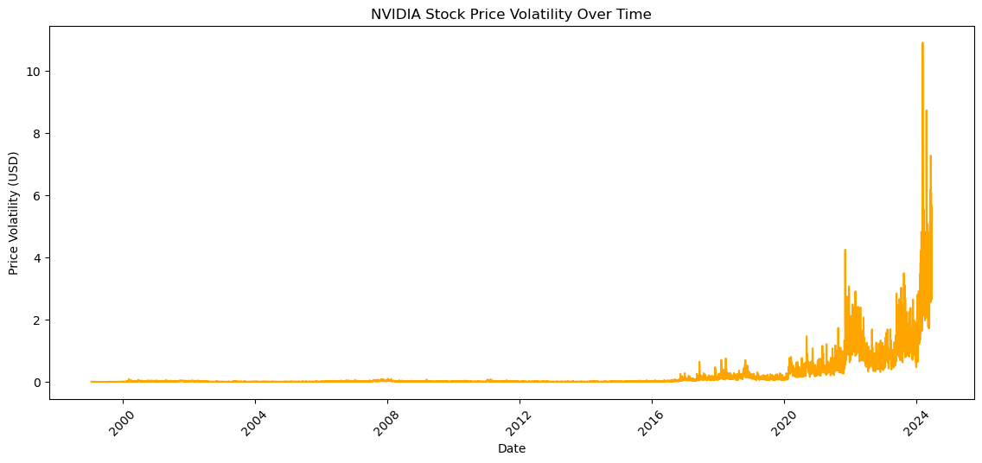

* + Comparison of RTX vs. GTX Releases: A time-based bar chart comparing how stock price reacted after the release of each series.

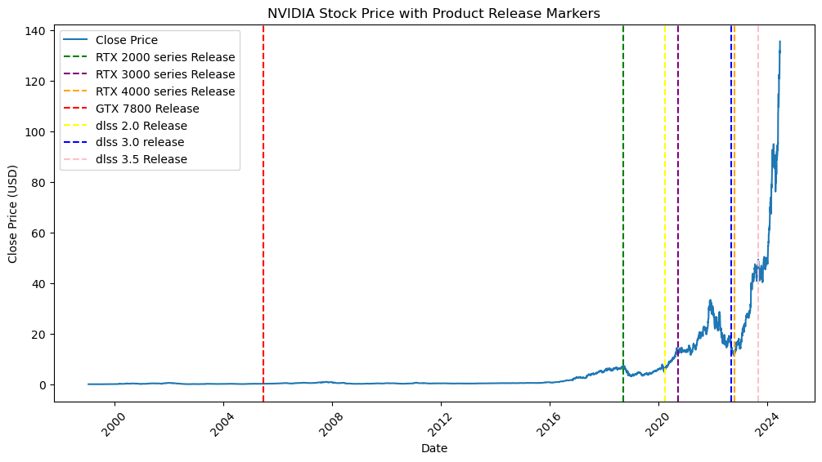

**Reasonability of Original Expectations:**

* The original expectations of classifying NVIDIA stock price movements seem feasible given the data, though the inherent unpredictability of markets often limits accuracy in such financial predictions. If early results show poor predictive accuracy, we may need to revisit assumptions regarding the influence of technological releases and incorporate more diverse data sources.